Контрольно-измерительные материалы
УМК Ю.А.Комарова, И.В.Ларионова, Ж.Перретт
«Английский язык», 4 класс
(Составители: Музейник Ю.А. – учитель английского языка высшей категории,
Прокина Н.Н.- учитель английского языка высшей категории)

Unit 2, 3
Control test.
Name ________________________________________
1.Прочитайте слова. Распределите по группам в соответствии с транскрипцией. –
(9 б.)
this, what, thank, that, those, where,
three, why, thirty
[Ɵ] | [ð] | [w]
2.Прочитайте слова. Распределите их в две колонки в соответствии со звучанием артикля. (6 б.)
the shop, the umbrella, the octopus,
the camp, the pirate, the ox
[ði:] | [ðǝ]
3.Соедините вопрос и ответ. Укажите букву ответа. (5б.)
1. Who are you? | E | A. She is Alice.
2. Where are you? |  | B. I’m in the house.
3. Where are they? |  | C. They are pirates.
4. Where is he? |  | D. They are at school.
5. Who are they? |  | E. I’m Bill.
6. Who is she? |  | F. He is at the sea.
4.Подпишите правильно названия школьного предмета. Используйте слова из рамки. (9 б.)
 | 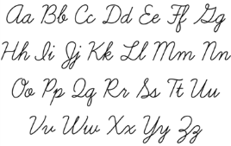
 | 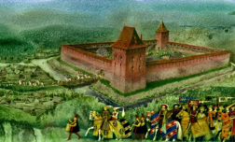 | 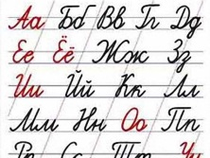
Music, Art, Geography, PE, Russian, English, Technology, History, Literature
5.Заполни таблицу. (Единственное и множественное число) – (5 б.)
a child
mice
people
a fox
a wolf
6. Вставь в пропуск соответствующее указательное местоимение this\that\these\those. – (6 б.)
1… | 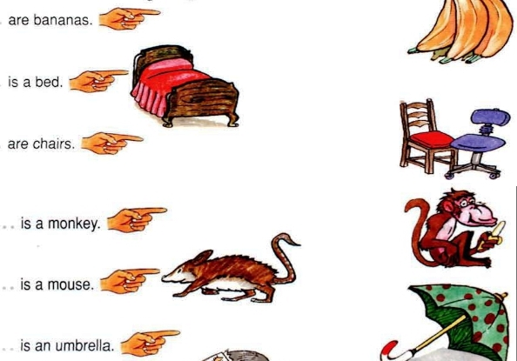
2…

3…

4…

5…

6…

7.Откройте скобки. Напишите правильную форму глагола. – (10 б.)
1. I (read) now. _________________________________________
2. They (play) now. ______________________________________
3. She (write) now._______________________________________
4. You (count) now.______________________________________
5. He (paint) now._______________________________________

50 - 48 | - - 36 | 35 - 24
Excellent! | Very good. | So-so.

Reading Test.
Name: _______________ Class:________
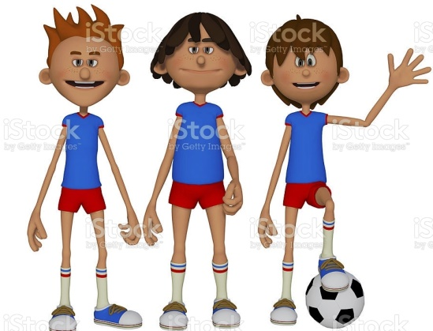
Hello!
My name is Steve. I am twelve. I am from Great Britain. I live in London, but now I am in Oxford.
In Oxford there is a campsite. In the campsite there are a lot of tents, trees, flowers and children.
I have two friends, David and Ben. We live together in the tent.
David is a sportsman. He likes PE. He likes playing tennis. But in the campsite David can play only football.
Ben likes to paint. He paints people, children and animals (cats, wolves, mice, foxes). His favourite subject is Art.
My family and I like travelling. We are planning to visit China or Korea. Last summer we visited Canada. My favourite subjects are History and Geography.

- Read the text. (Прочитай текст) – 5б.
- True/ false.
(Прочитай предложение, определи, где «правда», а где «ложь») – 5б.
- Steve is twenty. _____________
- Steve lives in Oxford. ______________
- In Oxford there are a lot of trees and flowers. __________
- Ben is a sportsman. ________________
- Last summer Steve visited Canada. _____________
- Answer the questions.(Ответь на вопросы по тексту) – 5б.
- Where is Steve from? ___________________________
- Where is Steve now? ____________________________
- Who likes playing tennis? ____________________________
- Who likes travelling? ____________________________
- Who likes painting? ____________________________
- Choose the words with the sound [ ð ].
(Найди в тексте слова со звуком [ ð ] и выпиши их) – 3б.
________________________________________________________________
- Find the words in plural form.
(Найди в тексте и запиши слова-исключения во множественном числе) – 3б.
________________________________________________________________
- Find the names of subjects in the text and write them.
(Выпиши названия школьных предметов из текста) – 4б.
___________________________________________________
7.* Draw a picture. (Нарисуй иллюстрацию к тексту)
25 -23 | 22-18 | 17-12
Excellent | Very good | Sad

Unit 4.
Control test.
Name ________________________________________
- Прочитай слова. Обрати внимание на выделенные буквы. Распредели слова по группам в соответствии с правилом чтения выделенного буквосочетания. – (15 б.)
whale, that, watch, shelf, three, children,
those, Maths, sheep, where, chair, this, tooth, white, Ashley
[Ɵ]
[ð]
[w]
[ʃ]
[tʃ]
- Прочитай слова. Распредели их по колонкам с соответствующей тематикой (9 б.)
English, tent, aunt, shop, History, parents, school, Art, cousin
FAMILY | CITY | LESSONS

3. Соедините вопрос и ответ. Укажите букву ответа в центральной колонке. (6 б.)
1. Who is she? | A | A. She is Alice.
2. Where are you? |  | B. They are in the shop.
3. Whose car is it? |  | C. Jill is his sister.
4. Where are they? |  | D. Patrick is his son.
5. Who is his sister? |  | E. I’m in the house.
6. Whose mum is she? |  | F. Peter’s mum
7. Who is Tom’s son? |  | G. It is Otto’s car.
4.Посмотри на картинки и ответь на вопросы к картинкам. Используй фразы из таблицы. (8 б.)
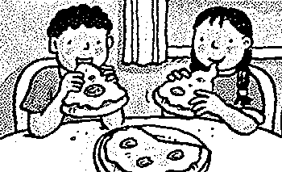
eat pizza | What are Tom and Alice doing?
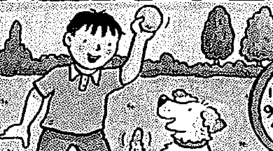
play with the dog | What is Ashton doing?
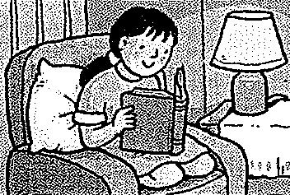
read a book | What is Maria doing?
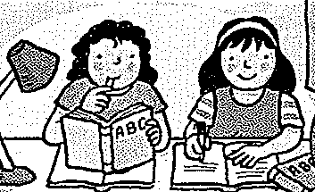
do homework | What is Anna and Helena doing?
5. Посмотри на часы и ответь на вопрос: What’s the time? Обведи верный ответ. (4 б.)
It’s four o’clock. | It’s half past four. | It’s half past four. | It’s a quarter past four.
It’s half past four. | It’s a quarter past four. | It’s half past five. | It’s a quarter to four.
It’s five o’clock. | It’s a quarter to four. | It’s five o’clock. | It’s a quarter to five.
6. Изучи информацию из таблицы. Заполни пропуски в предложениях, используя притяжательный падеж и притяжательные местоимения (his|her|their) (. (8б.)
Maria | Arabella | Patrick | Otto
bike | camera | dog | shop
- It’s ________________ dog. It’s _________dog.
- It’s _____________ camera. It’s _____ camera.
- It’s ____________ shop. It’s _______ shop.
- It’s ____________ bike. It’s ________ bike.
7.Прочитай внимательно текст. Прочитай утверждения к тексту. Определи правда это или ложь? (True – False). Обведи верный ответ.(5 б.)
Tony’s family.
This is Tony’s family. He has got parents Mary and Mike. His sister’s name is Alice. Bob and Jim are Tony’s brothers. Alice, Bob, Jim and Tony are Rebecca’s grandchildren. Rebecca is Mike’s mum. They are very friendly.
Tony and his brothers like to play football. Alice likes painting and playing with their dog Rex. Their grandmother likes reading history books . And Tony’s parents like playing board games. All together (все вместе) they like to have a picnic in the garden on Sundays.

1.Tony has got three brothers. – True \ False
2.Rebecca is Tony’s grandmother. – True \ False
3.Alice likes reading history books. – True \ False
4.Brothers like playing football. – True \ False
5.Tony’s family like to have a picnic in the forest. – True \ False

55 - 53 | 52 - 40 | 39 - 27
Excellent! | Very good. | So-so.

Unit 6,7.
Control test.
Name ________________________________________
- Listening. Аудирование. Прослушай и ответь на вопросы к тексту. (5 баллов)
Does Bertie like Arabella? | Yes, he does. | No, he doesn’t. | No, he don’t.
Does Brill make bread? | Yes, he does. | No, he doesn’t. | No, he don’t.
Do they sing and dance at Nora’s school? | Yes, they do. | Yes, they does. | No, they don’t.
Does Arabella like pictures? | Yes, she does. | No, she doesn’t. | No, she don’t.
Do Brill and Denzil want to see Bertie? | Yes, they do. | Yes, they does. | No, they don’t.

- Read the words. Fill in the gaps. Прочитай слова. Заполни пропуски на картинке. Подпиши названия времен года и недостающих месяцев. (12 баллов)
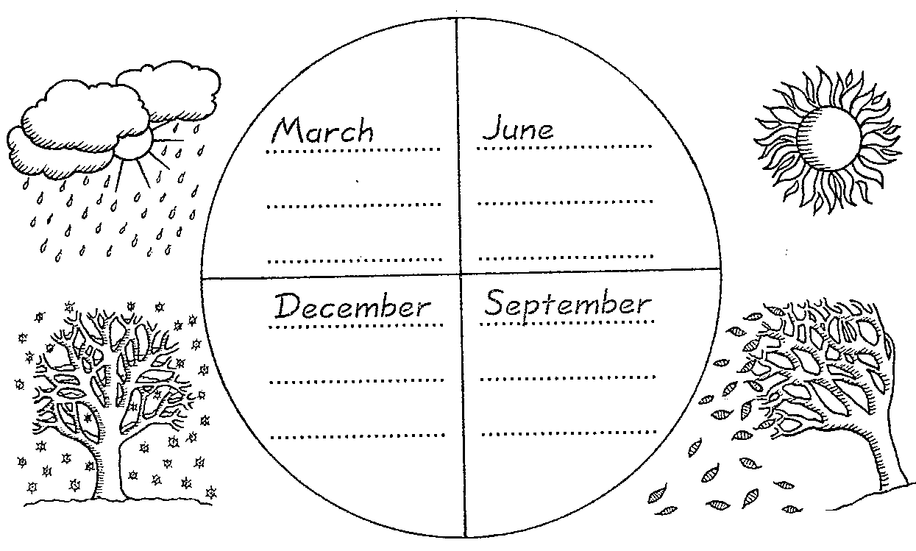
summer, autumn, spring, winter, October, July, August, April, November, January, May, February
- Fill in the gaps. Заполни пропуски в предложениях. Используй слова – often, sometimes, never. (5 баллов).
I _____________ drive a taxi.
I _______________ go to school.
I _____________ fly a plane.
I ____________ ride a bike in summer.
I ____________ help people.

- Choose the correct variant. Выбери правильный вариант глагола. (6 баллов).
A farmer usually … his tractor. | drive | drives
We often … a bike in summer. | ride | rides
A doctor … medicines to children. | give | gives
I always … with leaves in autumn. | play | plays
The children … to swim in the sea. | like | likes
… you run and jump in the puddles? | Do | Does
- The weather forecast. Прогноз погоды. Используй информацию из таблицы и пример для составления высказываний о погоде в разных городах. (8 баллов).
Tomsk
In Tomsk it is snowy and cold.
Moscow
1
London
2
Madrid
3
Tokio
4

- Read the text. What profession is it? Прочитай текст. О какой профессии идет речь? Закончи предложения. (5 баллов)
He likes animals. He drives a tractor. He grows pigs. He is a …
He helps people. He wears a uniform and drives a police car. He is a …
She reads and writes with children. She works at school. She is a …
She makes bread and cakes. She wears a uniform. She is a …
He wears a white uniform. He works in a hospital. He gives medicines. He is a …
gardener farmer worker policeman doctor teacher vet baker dancer driver

41 - 39 | 38-29 | 28-20
5 | 4 | 3

Итоговый тест
CONTROL TEST.
1. Group the words (сгруппируй слова) – 12 б.
Transport | Professions | Weather | Town
Cloudy, street, baker, windy, boat, park, plane, sunny, café, dancer, taxi, teacher
2.Choose the sound (определи верное звучание выделенных букв в слове и обведи верный вариант) – 8 б.
liked | [t] | [d] | [id]
played | [t] | [d] | [id]
painted | [t] | [d] | [id]
likes | [s] | [z] | [iz]
Otto’s | [s] | [z] | [iz]
Alice’s | [s] | [z] | [iz]
three |  | [ ] | [Ɵ]
this |  | [ ] | [Ɵ]
3. Read the text and fill in the gaps (прочитай текст и вставь пропуски) – 7 б.
Maria _______ in London. She has got a ____ dog Rex. Every morning she gets up at ______ ______ seven. She drinks _______ for breakfast and goes for a walk to the ______. Rex and Alice run and ______ in the park. But today it is cold and _______. They stay at home.
rainy, lives, coffee, nice, half past, play, park
4. Read the sentences and choose the correct verb (прочитай предложения и выбери правильный глагол) – 10 б.
1. Last summer we (go / went) to the zoo in London.
2. We (have / had) lunch at 12 o’clock every day.
3. Alice (paints / painted) a nice picture yesterday.
4. Bob (plays/played) tennis every Sunday.
5. I (am / is/ are) cooking a nice pizza.
6. They (am / is/ are) going to the park now.
7. Helen (am / is/ are) reading a book now.
8. Yesterday it (is / was) sunny and hot.
9. Today it (is / was) cloudy.
10. My friends (are / were) in the campsite last summer.
5. Make the sentences negative (переделай предложения в отрицательные высказывания) – 3
Maria played the piano last Monday.
Maria didn’t play the piano last Monday.
Bob painted a picture for his mother.
I visited my friend last Sunday.
They jumped in the playground yesterday.
6. Прочитай текст. Пронумеруй картинки в соответствии с текстом. Определи, правдивы ли высказывания к тексту. – 5 + 7 б.
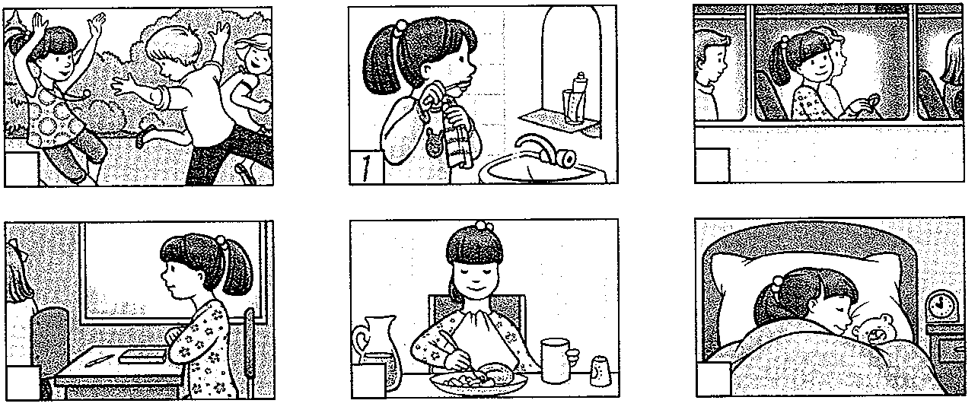
Ann gets up at seven o’clock every day. She washes her face, cleans her teeth and has breakfast. Then she goes to school on a school bus. Her school starts at half past eight and finishes at two. Anna has got five lessons every day. She hasn’t got any lessons on Saturday and Sunday. After school Ann goes home and has dinner. Her favourite food is chicken and potatoes. Then she does her homework and goes to the park with her friends. She goes to bed at half past nine.
Ann gets up at 8 o’clock every day. | T | F
She goes to school by school bike. | T | F
Her school starts at half past eight. | T | F
She has got five lessons every day. | T | F
Ann goes to school on Saturday. | T | F
Ann likes chicken and potatoes. | T | F
Ann goes to the park with her friends. | T | F

52 - 50 | 49 - 37 | 36 -25
5 | 4 | 3

